**End-to-End Amazon App Deployment using Terraform, Jenkins CI/CD, Docker, and Monitoring with Prometheus & Grafana**

we are going to deploy amazon app in aws ec2 **using terraform as a infrastructure building tool** and then we a**utomate the whole process using the jenkins** which allows us continuous integration and continuous deployment (ci-cd) and then we setup Promotheus and grafana for monitering

## Pre-requisite

aws account

basics of [terraform](https://medium.com/@aakibkhan1/terraform-infrastructure-building-tool-1a8a5ab27800) and [jenkins](https://medium.com/@aakibkhan1/jenkins-part-1-the-heart-of-software-development-lifecycle-eeaf1f80f59c)

Let’s do it

## before do anything →

open your terminal and make a separate folder for amazon →mkdir amazon

cd amazon

clone the github repo

git clone <https://github.com/Aakibgithuber/Amazon-app-Deployment-using-terraform-and-jenkins.git>

## Completion steps →

**Step 1 → Setup Terraform and configure aws on your local machine**

**Step 2 → Building a simple Infrastructure from code using terraform**

**Step 3 → Setup Sonarqube and jenkins**

**Step 4 → ci-cd pipeline**

**Step5 →Monitering via Prmotheus and grafana**

**Step 6 → Terraform Destroy**

# Step 1 → Setup Terraform and configure aws on your local machine

## 1. Setup Terraform

To install terraform copy and paste the below commands

sudo su  
snap install terraform --classicwhich terraform



## 2. Configure aws

**create an IAM user**

go to your aws account and type IAM

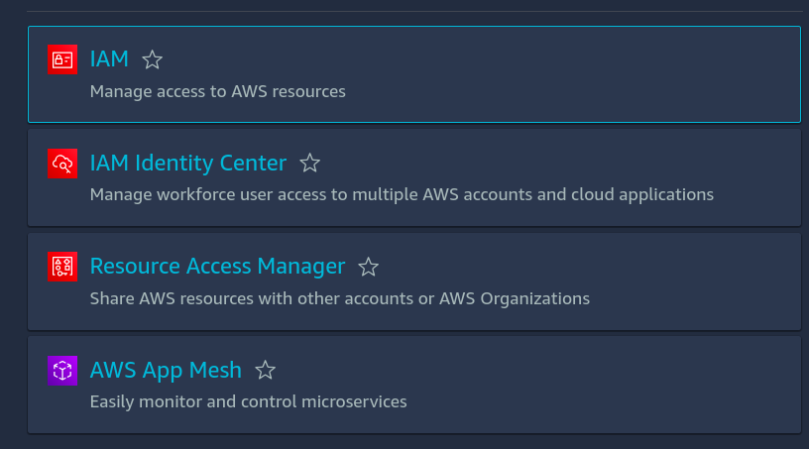

click on iam

**3. click on user →create user**

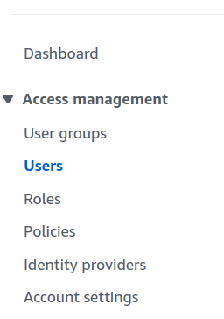

**4. Give a name to your user and tick on provide user access to management console and then click on I want an IAM user option**

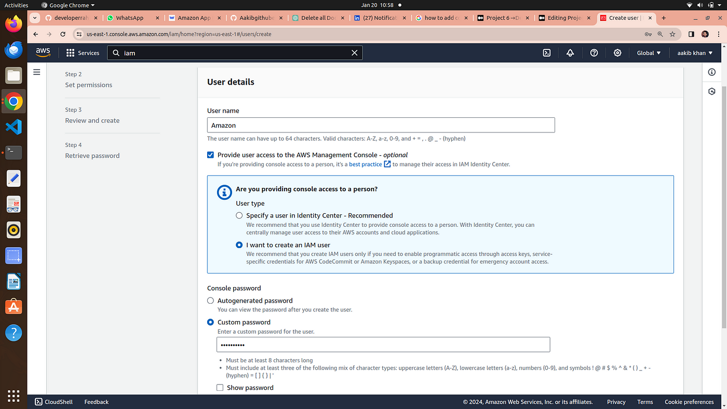

5. choose a password for your user **→click next**

6. Attach the policies directly to your iam user → click next

**note →I will provide the administrator accesss for now but we careful while attaching the policies on your workapce**

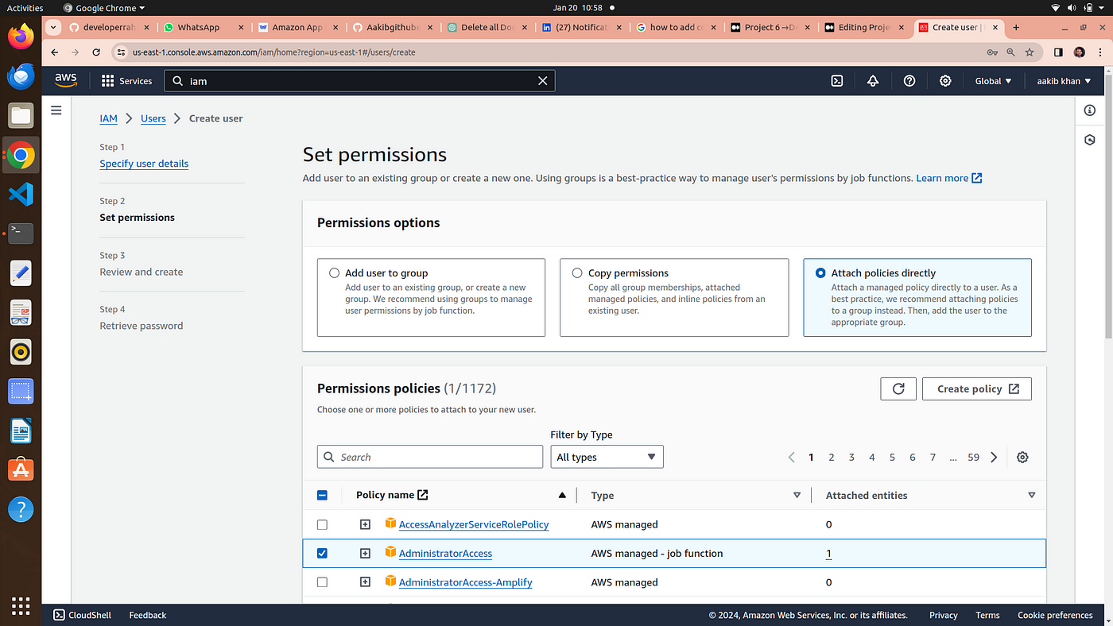

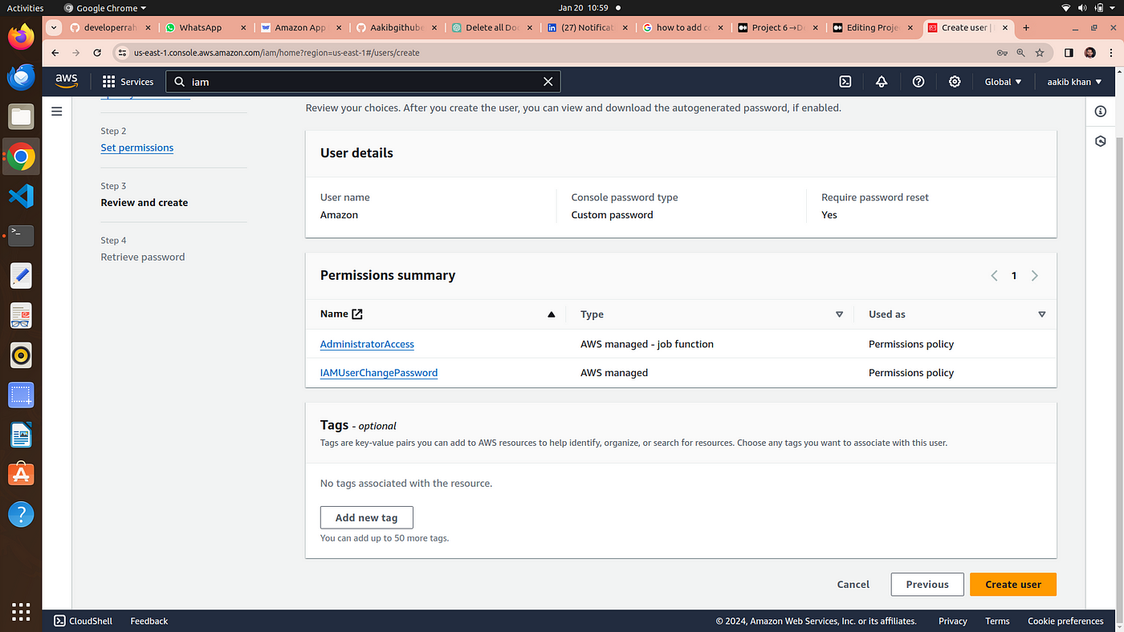

review and create user

7. click on **create user**

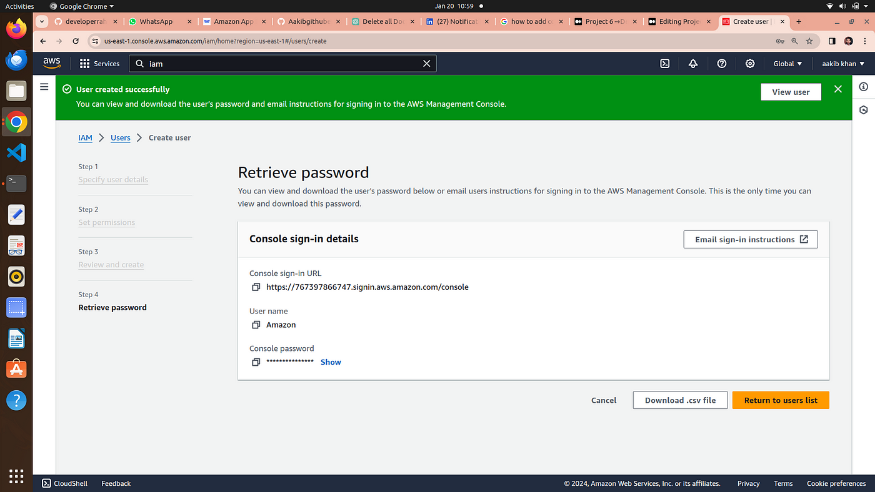

8. download your password file if it is autogenerated otherwise it is your’s choice

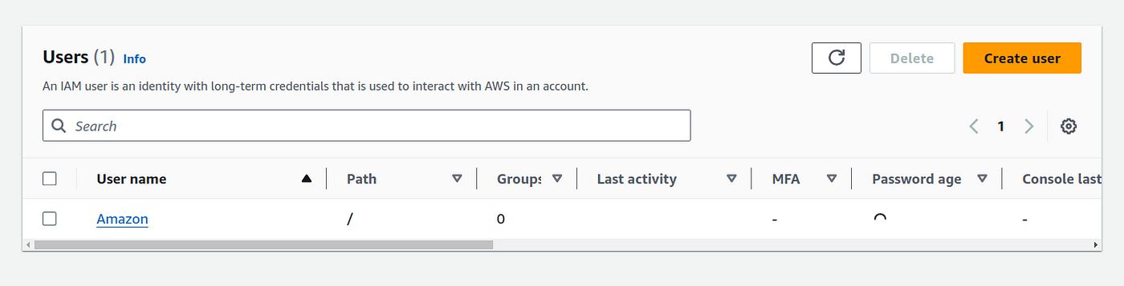

9. Now **click on your IAM user →security credentials**

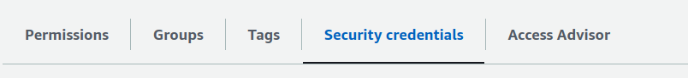

10. scroll down to access keys and create an access keys

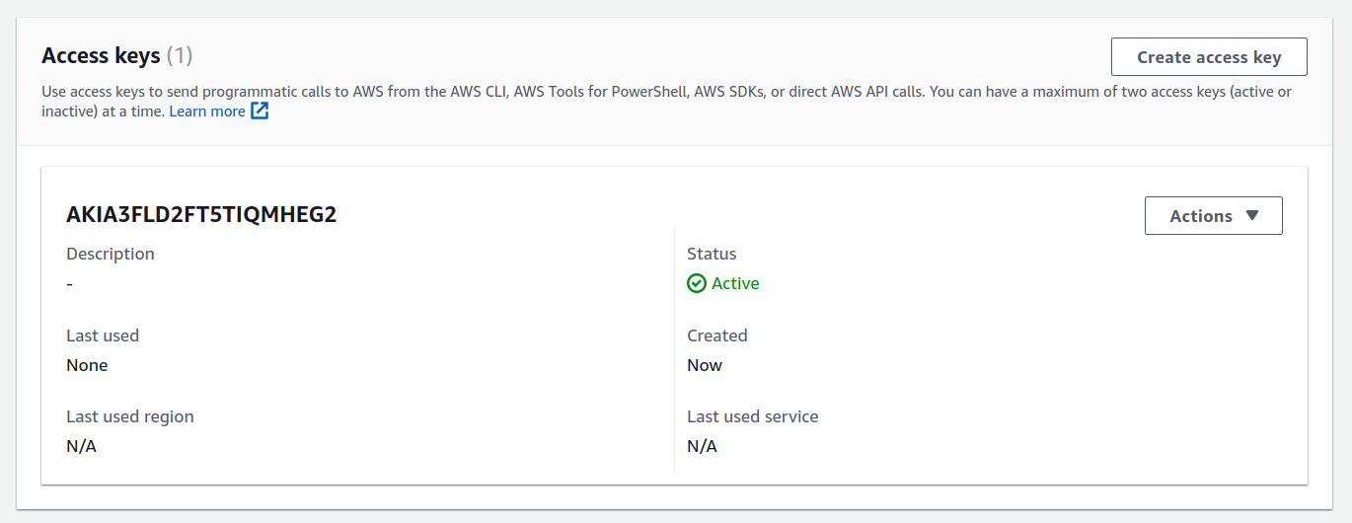

11.**choose aws cli from the options listed**

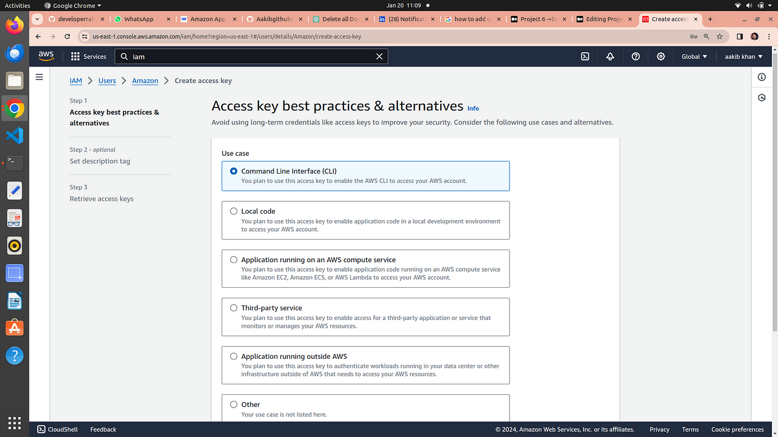

**12.** click next and download you csv file for username and password

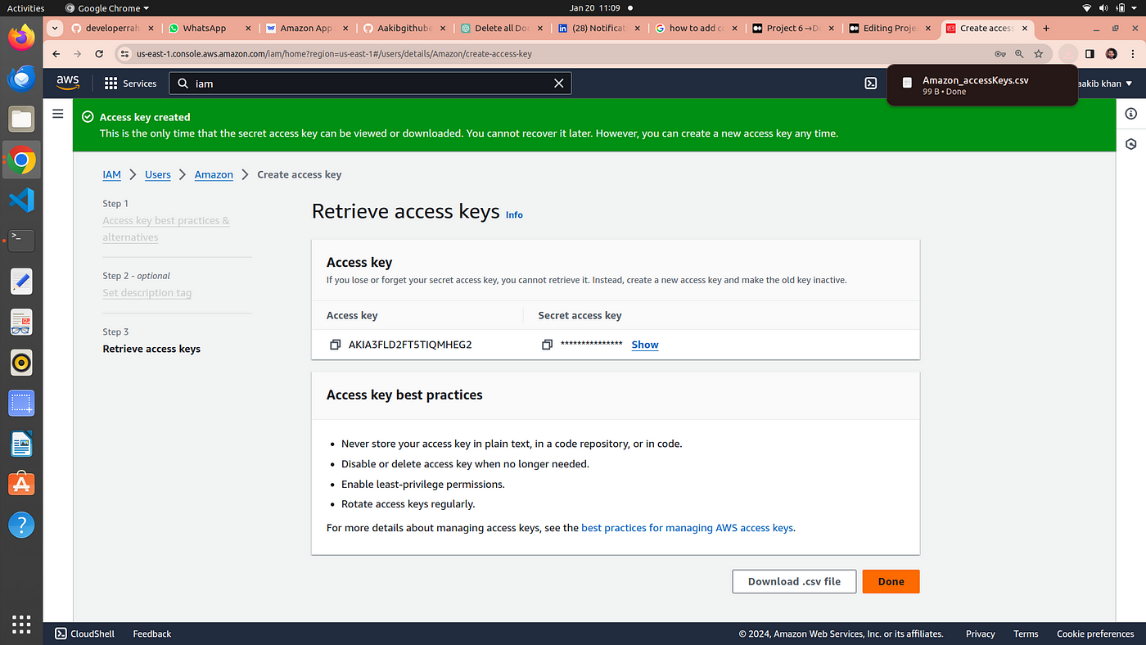

**13.** go to your terminal and type →aws configure

**14.** Now it is ask to your access key and secret key for this open your csv file and paste the access and secret key and remain everything default

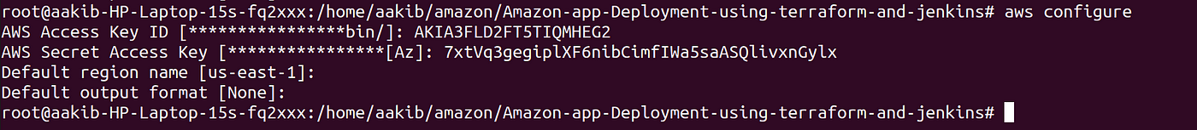

**15.** Now you are ready to configure aws from your terminal

# Step 2 → Building a simple Infrastructure from code using terraform

go to folder → cd JENKINS-TF

there are three files present main.tf, install_jenkins.sh , provider.tf

open the file →vim Main.tf

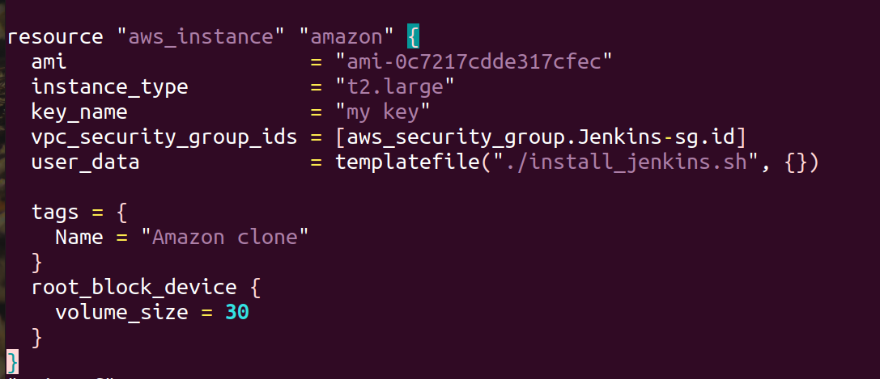

**4. change this section → ami = # your ami id , key_name= #your key pair if any**

## Now run terraform commands →

**main.tf includes userdata which links install_jenkins.sh file on which execution install jenkins,docker,trivy,and start the sonarqube container on port 9000**

resource "aws_security_group" "Jenkins-sg" {  
 name = "Jenkins-Security Group"  
 description = "Open 22,443,80,8080,9000"  
  
 # Define a single ingress rule to allow traffic on all specified ports  
 ingress = [  
 for port in [22, 80, 443, 8080, 9000, 3000] : {  
 description = "TLS from VPC"  
 from_port = port  
 to_port = port  
 protocol = "tcp"  
 cidr_blocks = ["0.0.0.0/0"]  
 ipv6_cidr_blocks = []  
 prefix_list_ids = []  
 security_groups = []  
 self = false  
 }  
 ]  
  
 egress {  
 from_port = 0  
 to_port = 0  
 protocol = "-1"  
 cidr_blocks = ["0.0.0.0/0"]  
 }  
  
 tags = {  
 Name = "Jenkins-sg"  
 }  
}  
  
  
resource "aws_instance" "web" {  
 ami = "ami-0c7217cdde317cfec"  
 instance_type = "t2.large"  
 key_name = "my key"  
 vpc_security_group_ids = [aws_security_group.Jenkins-sg.id]  
 user_data = templatefile("./install_jenkins.sh", {})  
  
 tags = {  
 Name = "amazon clone"  
 }  
 root_block_device {  
 volume_size = 30  
 }  
}terraform init  
terraform validate  
terraform plan  
terraform apply --auto-approve

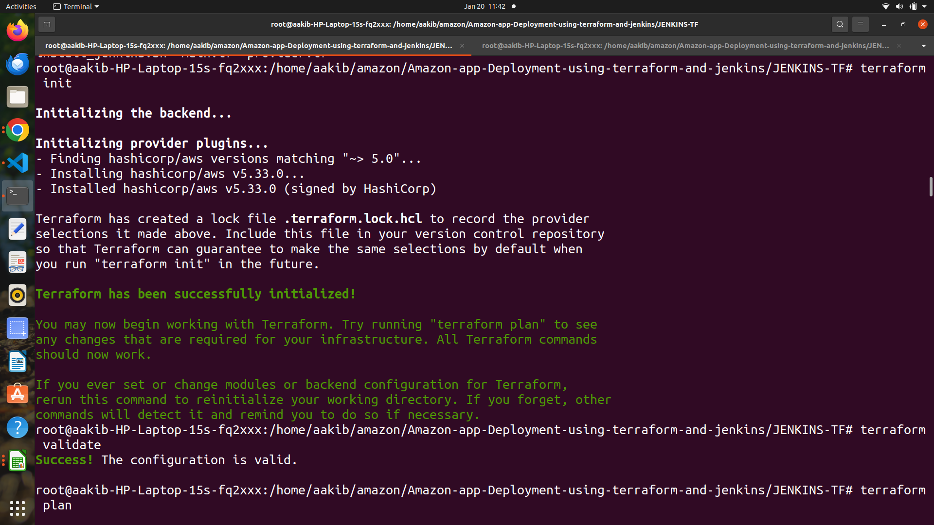

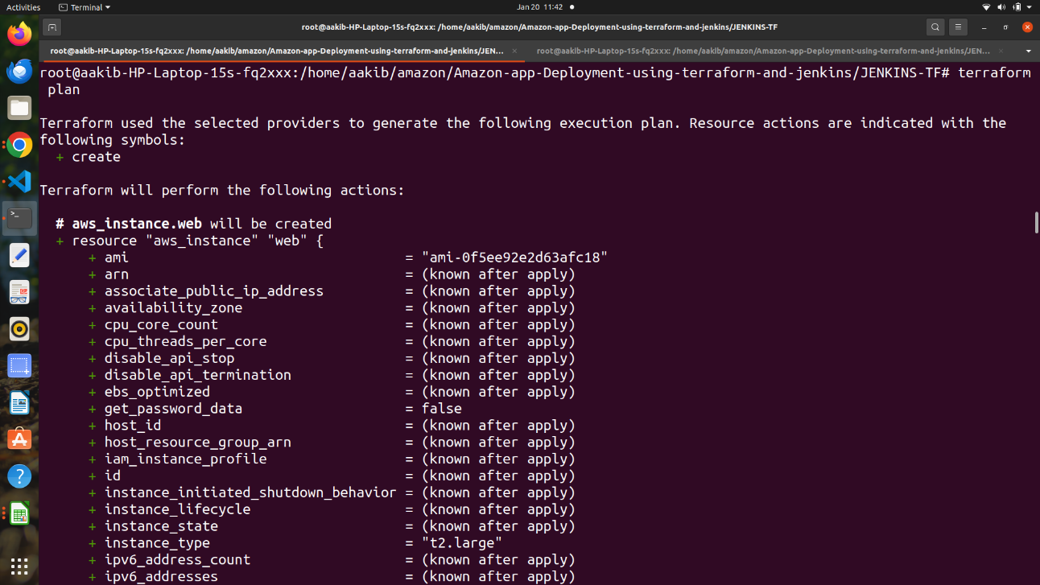

terraform init,validate and plan output

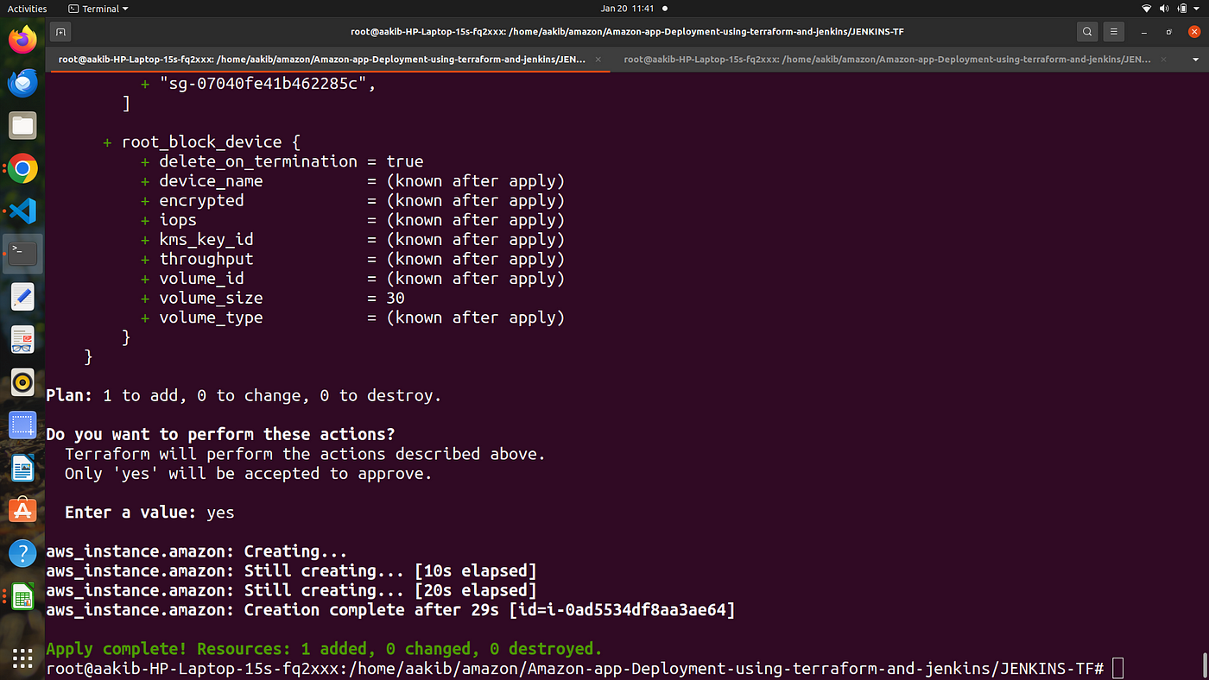

terraform apply

**Go to your aws console and checkout the ec2 instances**

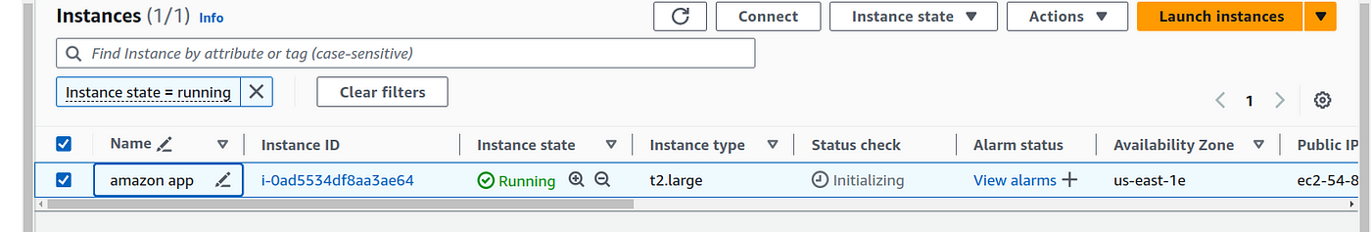

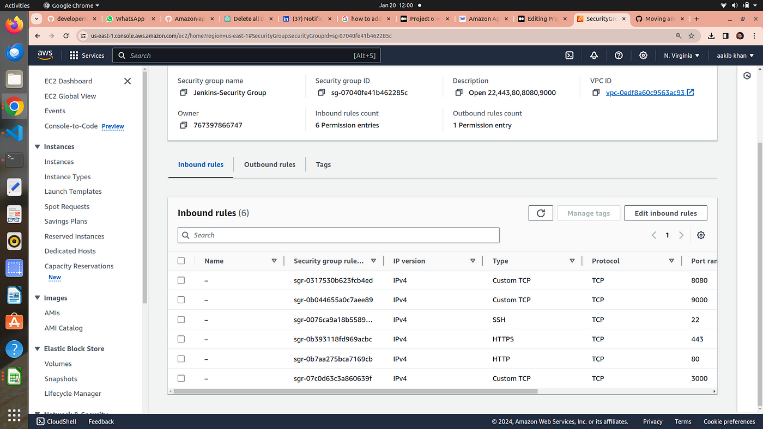

ports that are listed in main.tf to be opened

**Here we see amazon app instance is created by terraform with the given configuration**

# Step 3 → Setup Sonarqube and jenkins

## 1.Sonarqube →

copy the public ip of your machine

**go to your browser and type →<publicip>:9000**

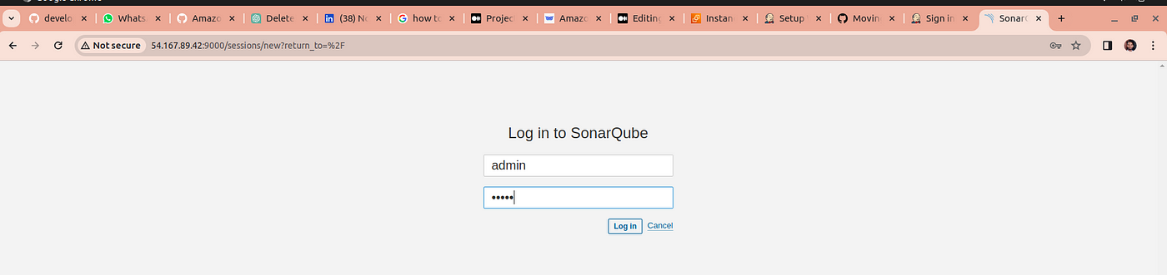

sonarqube window open

**2.** iniatially username and password is admin

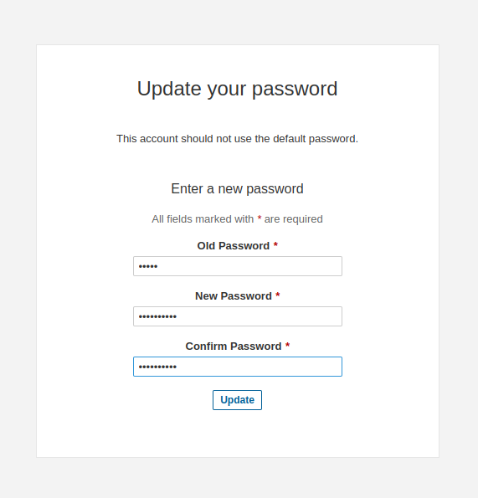

**3.** update your password

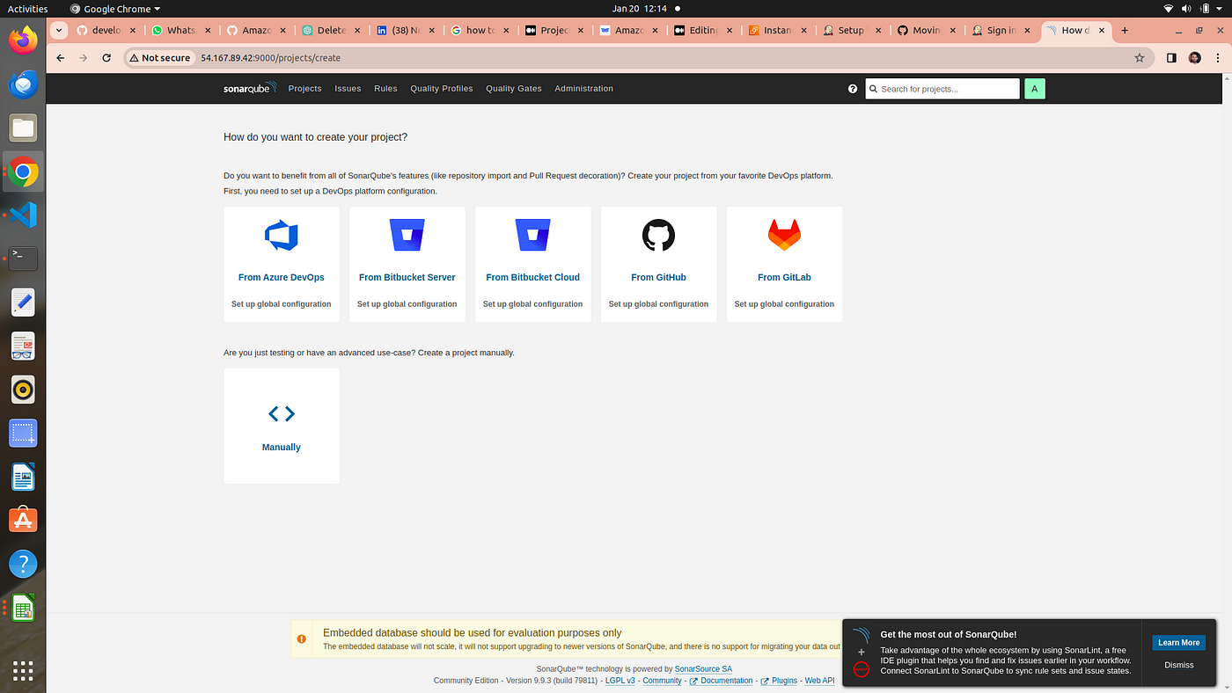

**4.** welcome window of Sonarqube

## 2. Jenkins →

**on browser type →<public_ip>:8080**

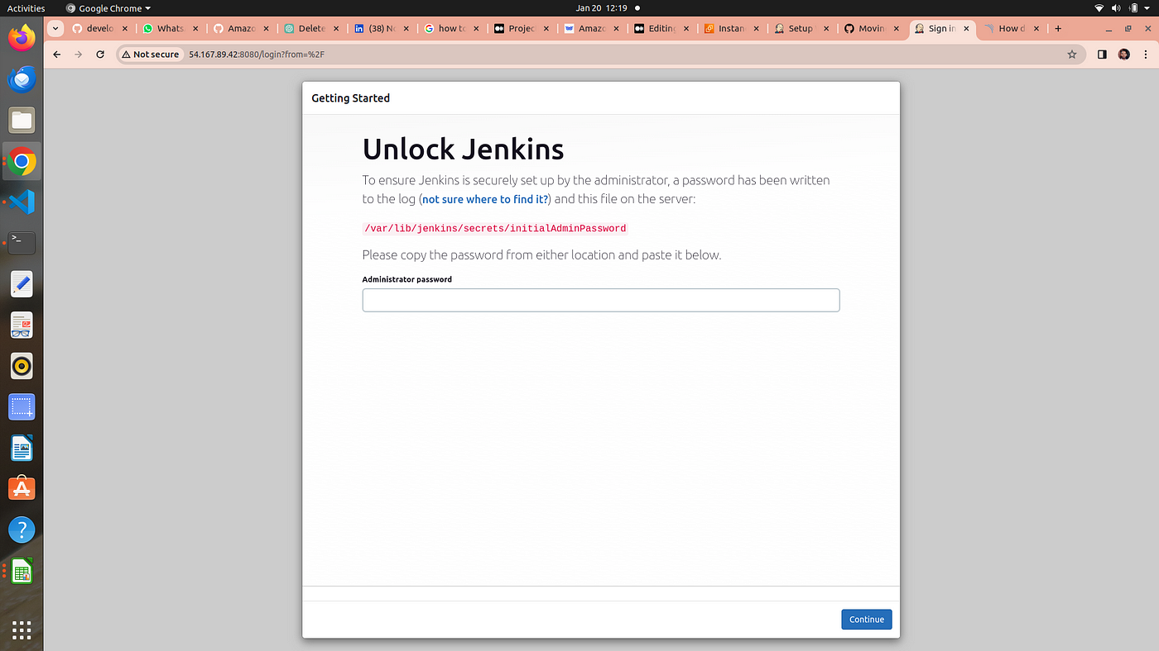

**2.** for this go to your ec2 and connect it

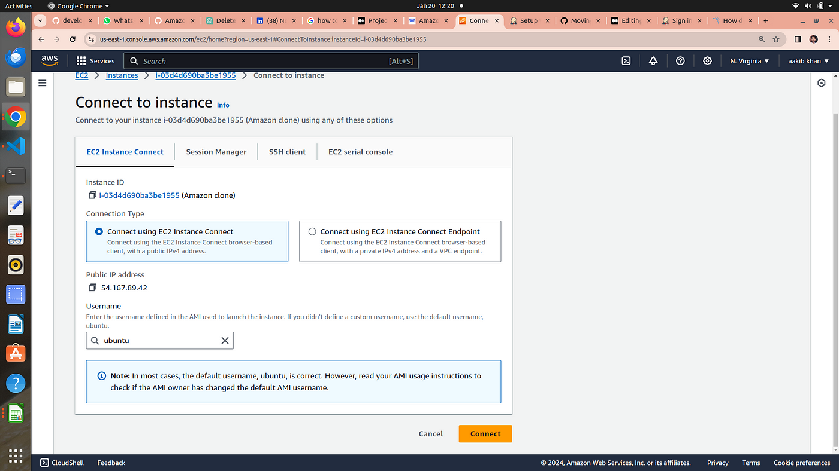

3. run the below commands

sudo su  
cat /var/lib/jenkins/secrets/initialAdminPassword



**output is your password and paste it to your jenkins**

**4. Install the suggested plugins**

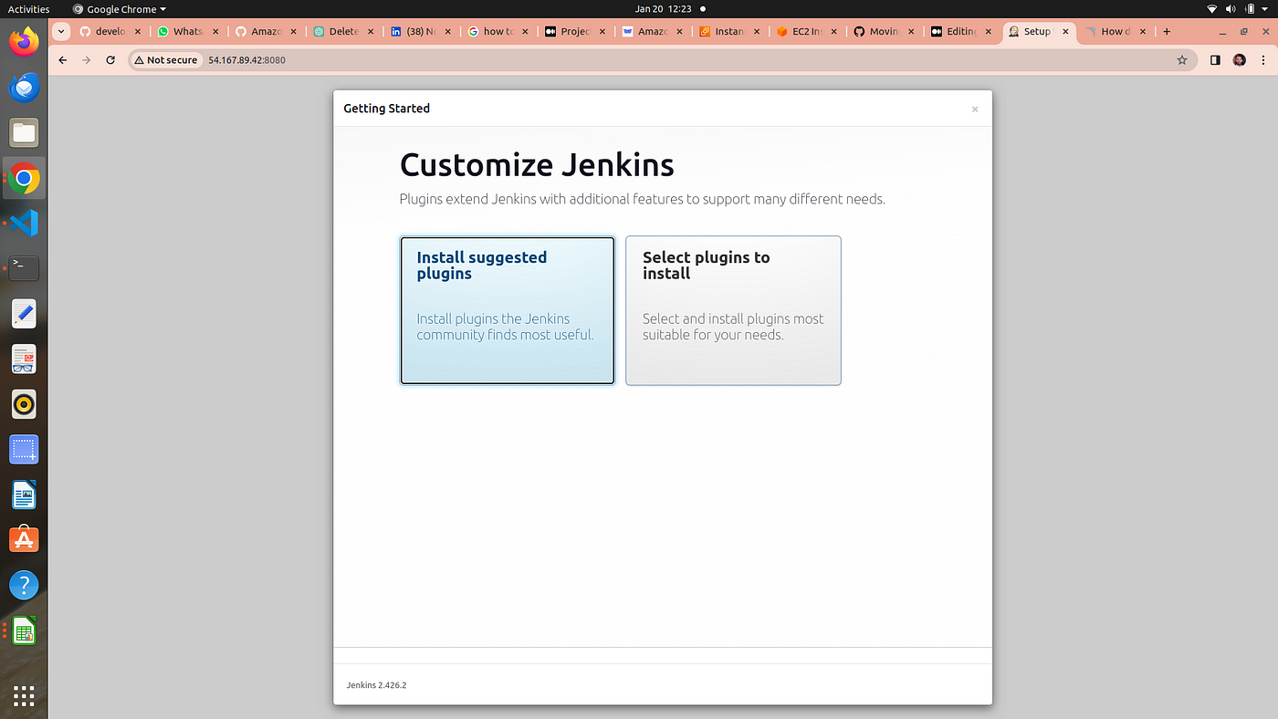

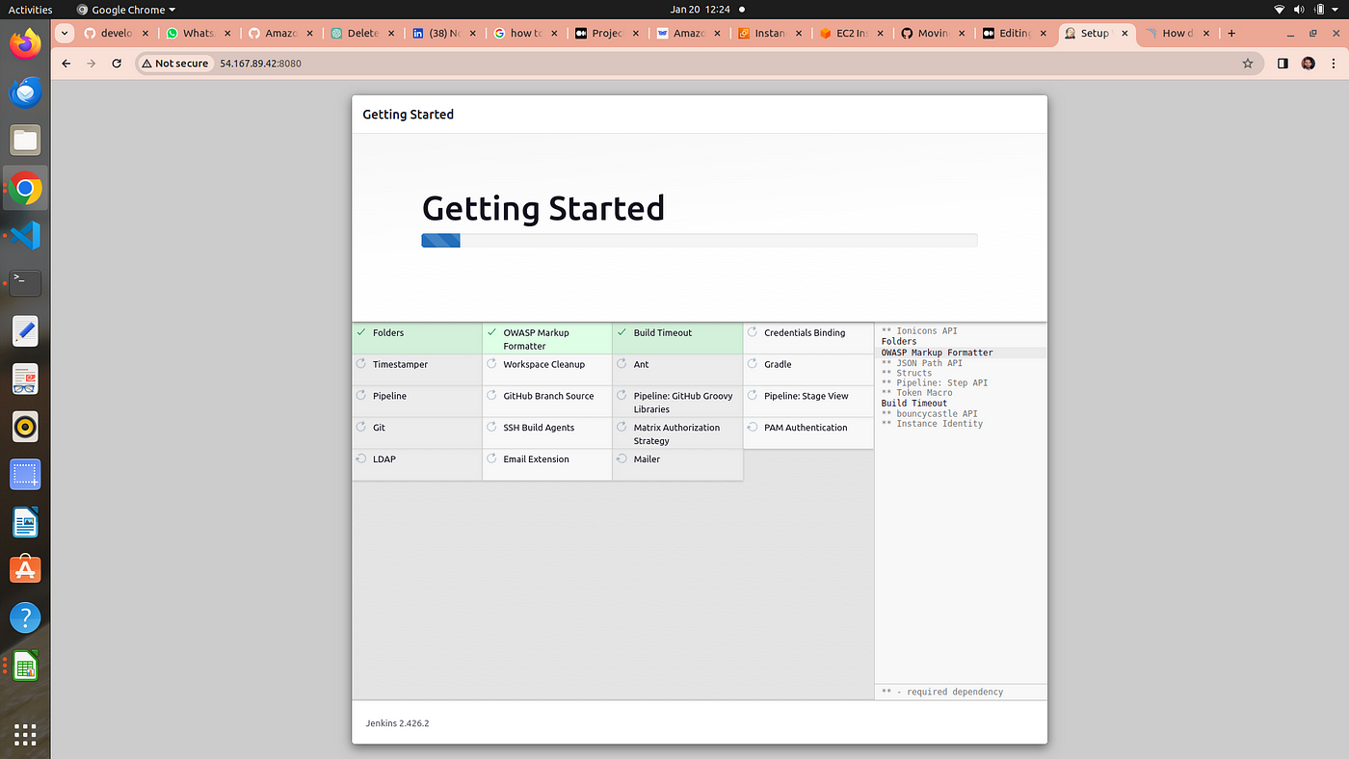

**5. Setup your jenkins user**

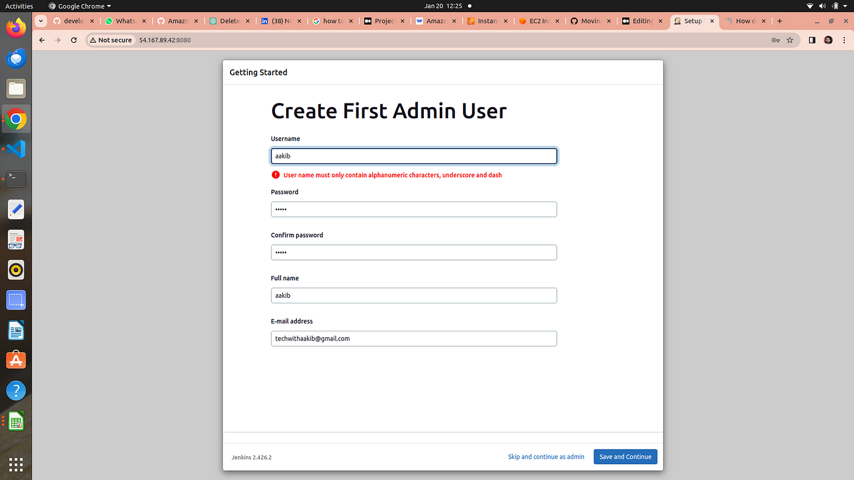

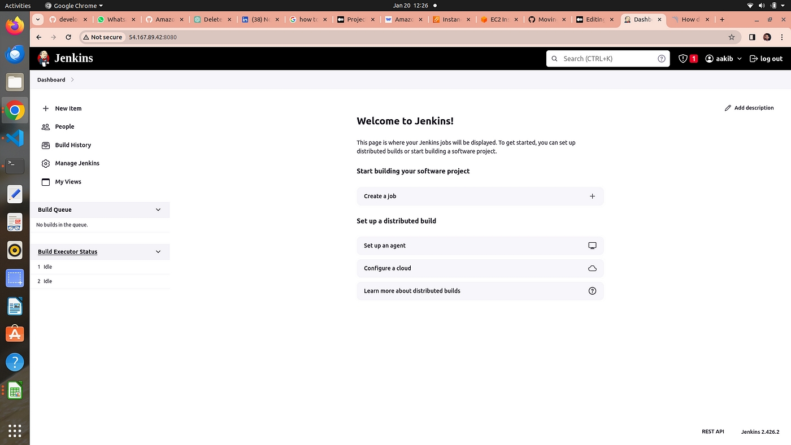

Welcome to jenkins dashboard

# Step 4 → ci-cd pipeline

## 1. Install Plugins listed below

1 Eclipse Temurin Installer (Install without restart)

2 SonarQube Scanner (Install without restart)

3 NodeJs Plugin (Install Without restart)

4. **owasp →**The OWASP Plugin in Jenkins is like a “security assistant” that helps you find and fix security issues in your software. It uses the knowledge and guidelines from the Open Web Application Security Project (OWASP) to scan your web applications and provide suggestions on how to make them more secure. It’s a tool to ensure that your web applications are protected against common security threats and vulnerabilities.

5. Prometheus metrics →to moniter jenkins on grafana dashboard

6. Download all the docker realated plugins

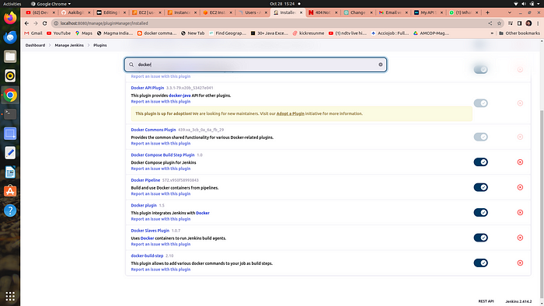

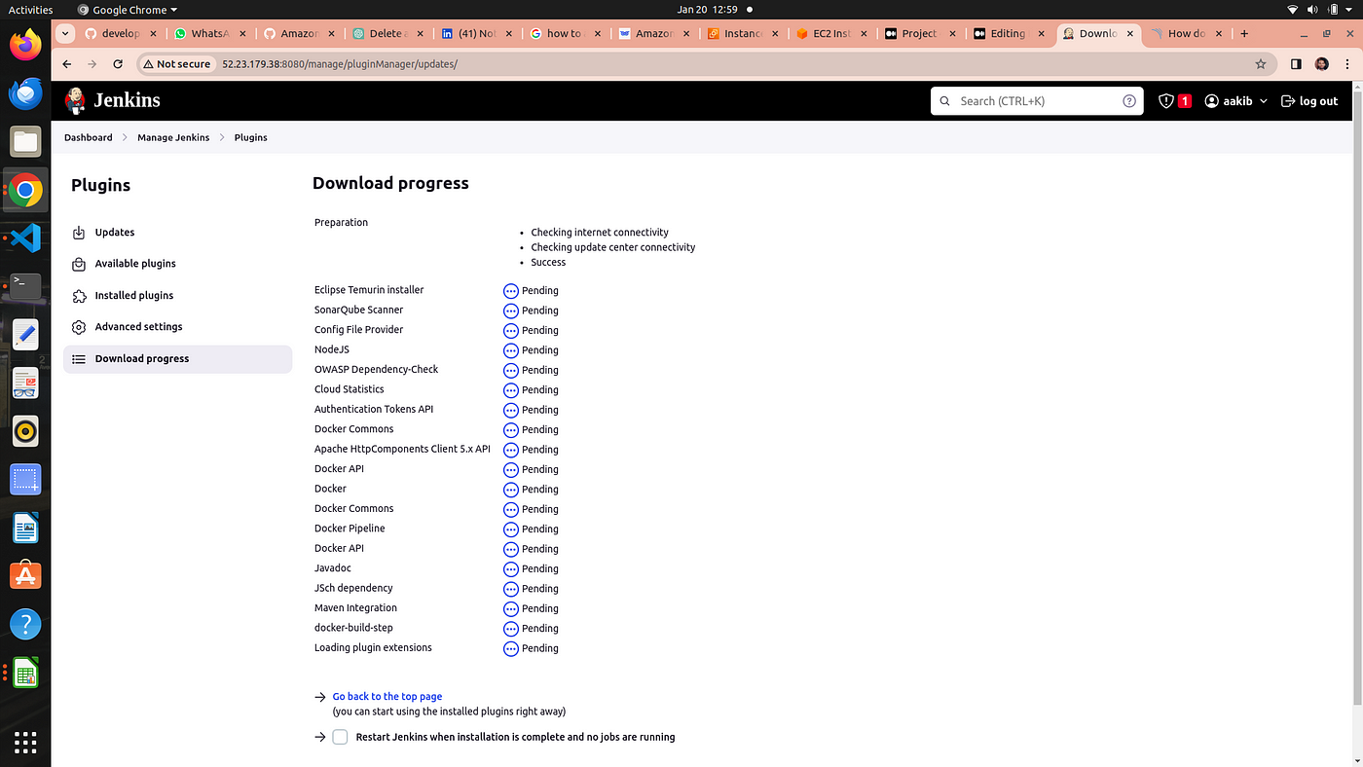

# 2. add credentials of Sonarqube and Docker

1st we genrate a token for sonarqube to use in jenkins credentials as secret text

# a. setup sonarqube credentials

go to [http://publicip:9000](http://publicip:9000/)

now enter your username and password

click on security →users →token →generate token

token_name==jenkins

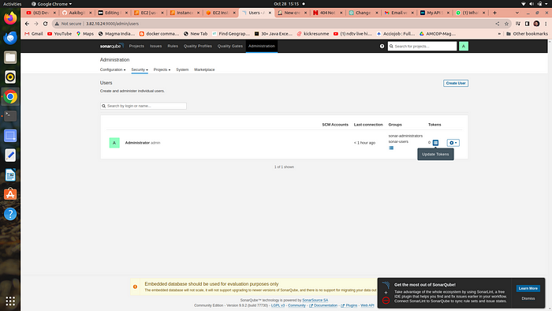

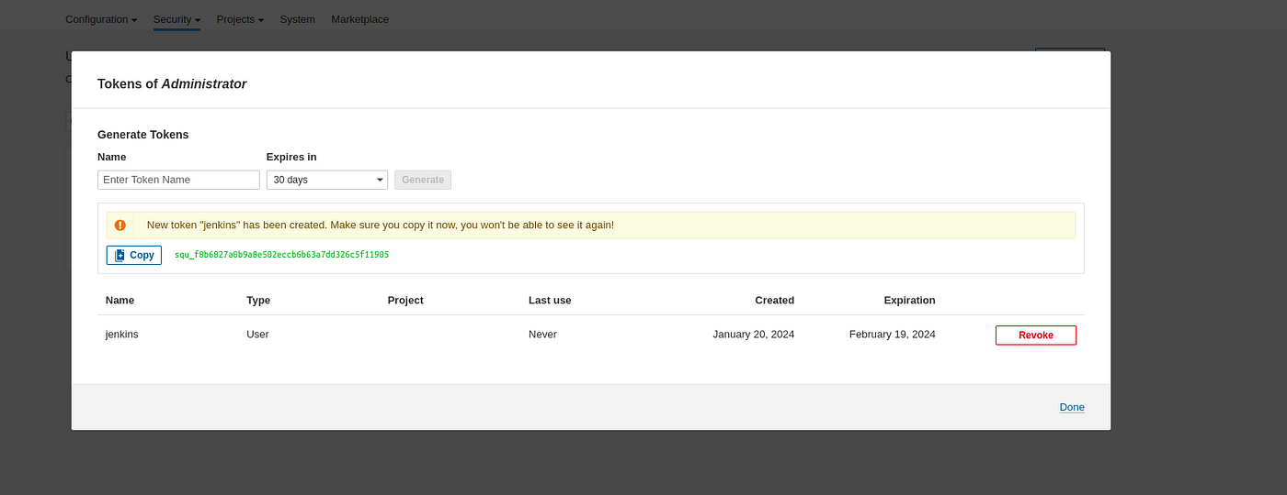

**4. copy the token and go to your jenkins →manage jenkins →credentials →global →add credentials**

**5. select secret text from dropdown**

**6. secret text ==your token , id =jenkins →click on create**

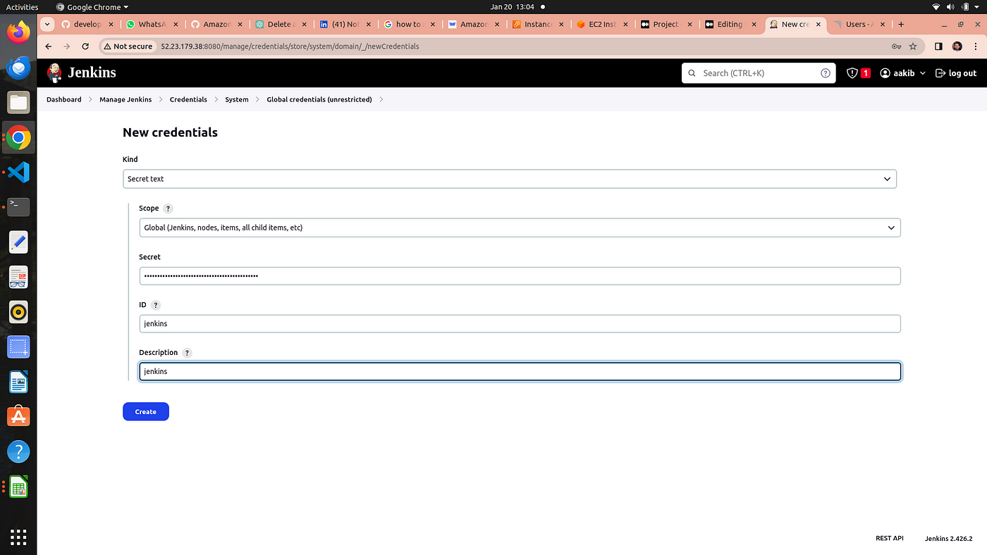

# b. setup projects in sonarqube for jenkins

go to your sonarqube server

click on projects

in the name field type Amazon

click on set up

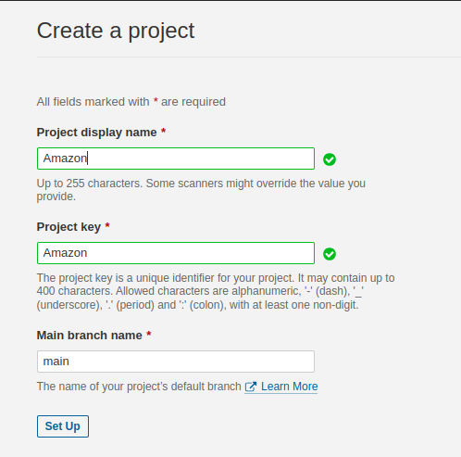

click on setup

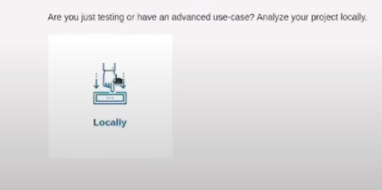

click on above option

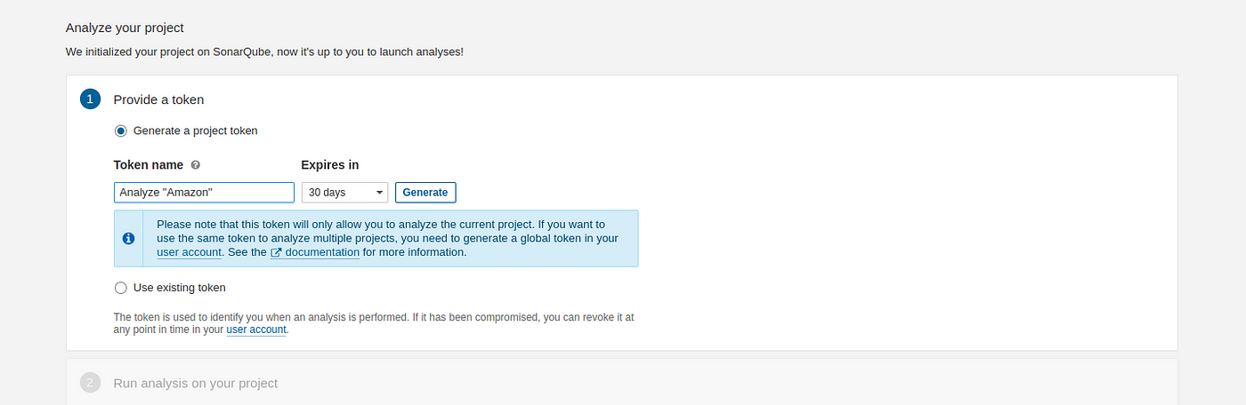

click on generate

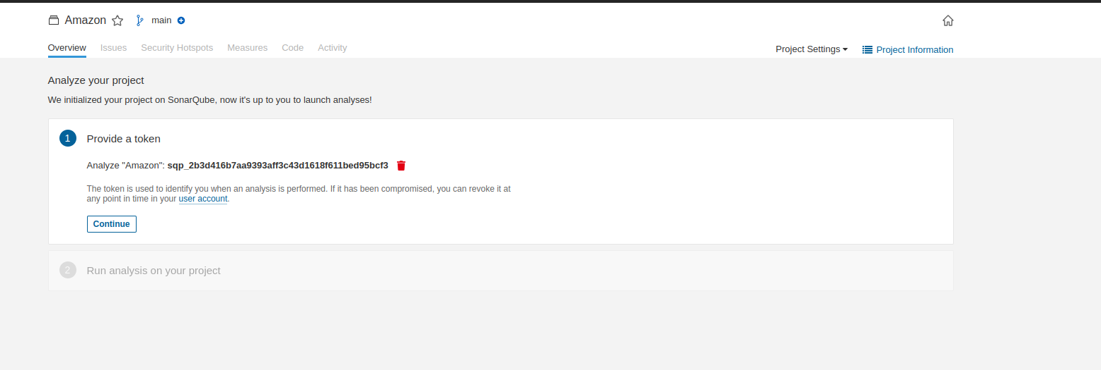

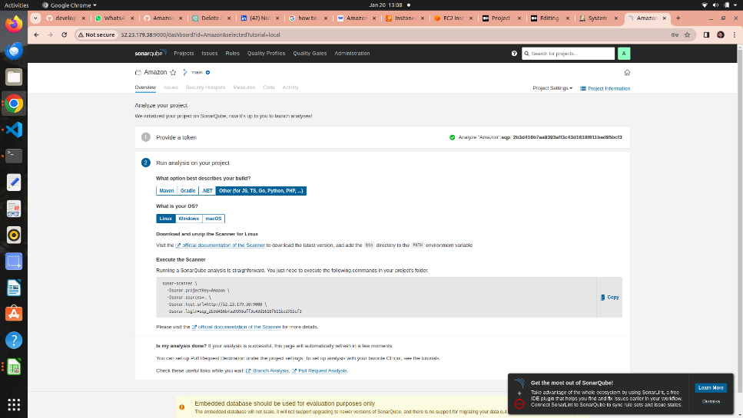

click on continue ….

**Sonarqube project for jenkins is setup now**

# c. Setup docker credentials

go to your jenkins →manage jenkins →credentials →global →add credentials

provide your username and password of your dockerhub

id==docker

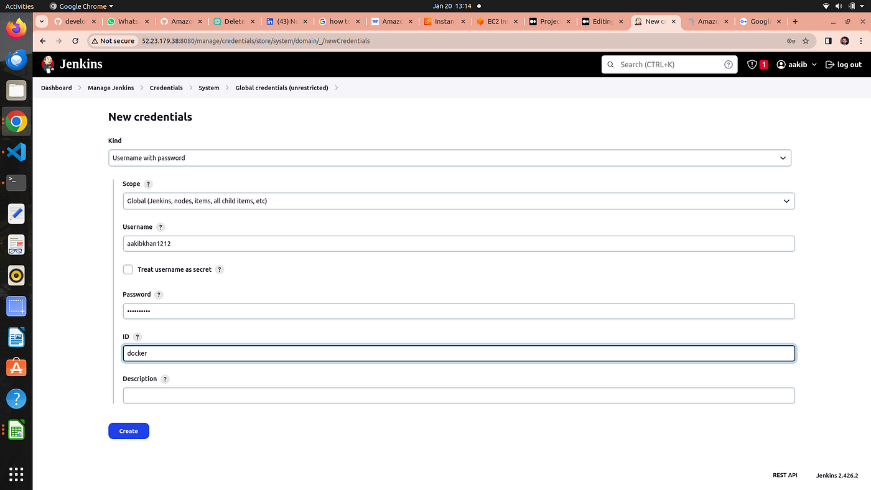

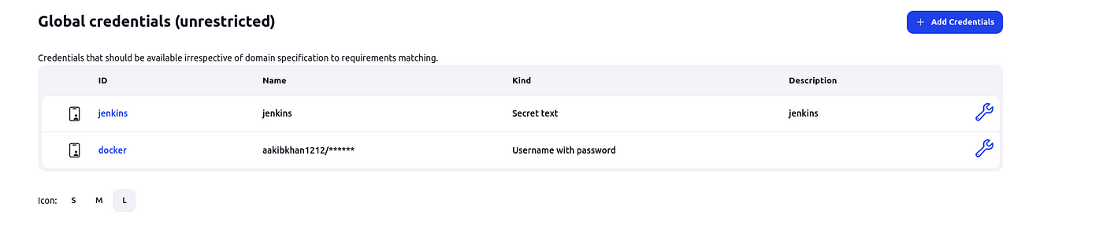

credentials for both are setup

# 3. Now we are going to setup tools for jenkins

**go to manage jenkins → tools**

# a. add jdk

click on add jdk and select installer adoptium.net

choose jdk 17.0.8.1+1version and in name section enter jdk 17

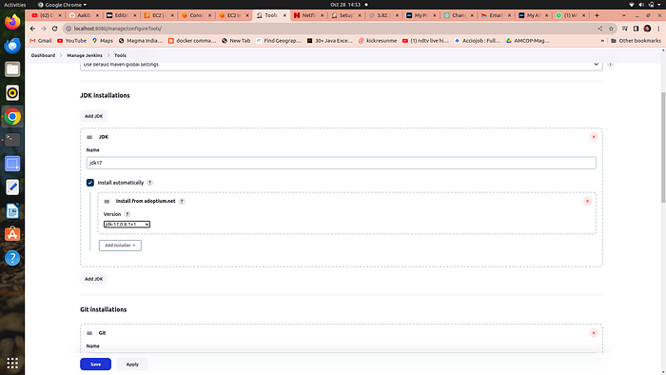

# b. add node js

click on add nodejs

enter node16 in name section

choose version nodejs 16.2.0

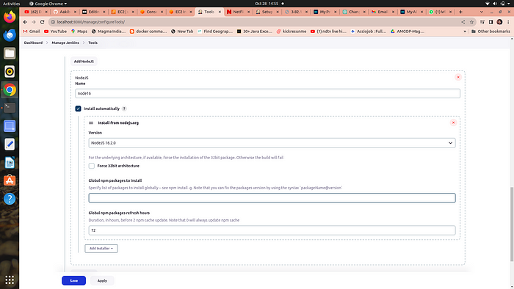

# c. add docker →

click on add docker

name==docker

add installer ==download from docker.com

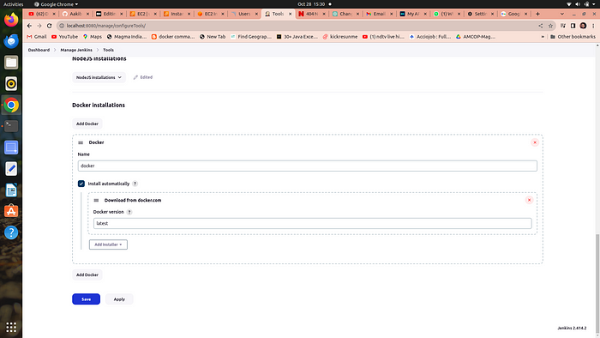

# d. add sonarqube →

add sonar scanner

name ==sonar-scanner

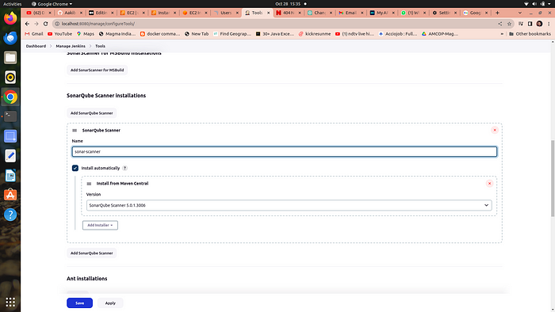

# e. add owasp dependency check →

Adding the Dependency-Check plugin in the “Tools” section of Jenkins allows you to perform automated security checks on the dependencies used by your application

add dependency check

name == DP-Check

from add installer select install from github.com

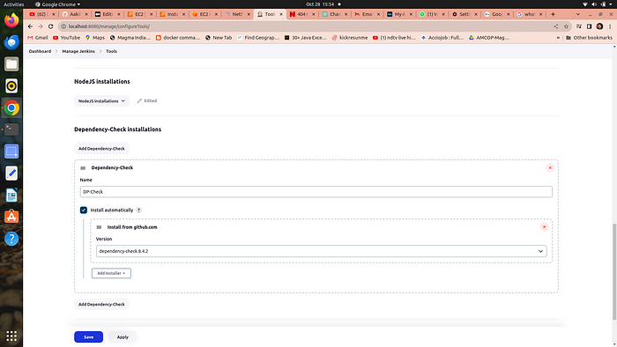

# Step 4 →Configure global setting for sonarube

**go to manage jenkins →Configure global setting →add sonarqube servers**

n**ame ==sonar-server**

**server_url==http://public_ip:9000**

**server authentication token == jenkins →it is created in sonarqube security configurations**

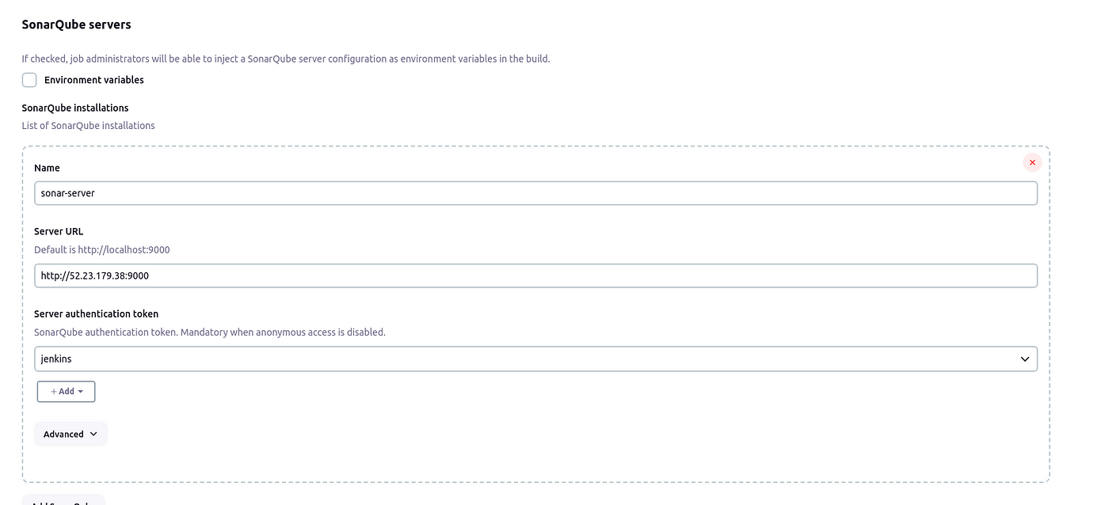

# 4. let’s run the Pipeline →

**go to new item →select pipeline** →in the name section type **amazon-pipeline**

scroll down to the **pipeline script** and copy paste the following code

pipeline{  
 agent any  
 tools{  
 jdk 'jdk17'  
 nodejs 'node16'  
 }  
 environment {  
 SCANNER_HOME=tool 'sonar-scanner'  
 }  
 stages {  
 stage('clean workspace'){  
 steps{  
 cleanWs()  
 }  
 }  
 stage('Checkout from Git'){  
 steps{  
 git branch: 'main', url: 'https://github.com/Pudaykumar16/amazon/tree/main/Amazon-app-Deployment-using-terraform-and-jenkins'  
 }  
 }  
 stage("Sonarqube Analysis "){  
 steps{  
 withSonarQubeEnv('sonar-server') {  
 sh ''' $SCANNER_HOME/bin/sonar-scanner -Dsonar.projectName=Amazon \  
 -Dsonar.projectKey=Amazon '''  
 }  
 }  
 }  
 stage("quality gate"){  
 steps {  
 script {  
 waitForQualityGate abortPipeline: false, credentialsId: 'jenkins'   
 }  
 }   
 }  
 stage('Install Dependencies') {  
 steps {  
 sh "npm install"  
 }  
 }  
 stage('OWASP FS SCAN') {  
 steps {  
 dependencyCheck additionalArguments: '--scan ./ --disableYarnAudit --disableNodeAudit', odcInstallation: 'DP-Check'  
 dependencyCheckPublisher pattern: '**/dependency-check-report.xml'  
 }  
 }  
 stage('TRIVY FS SCAN') {  
 steps {  
 sh "trivy fs . > trivyfs.txt"  
 }  
 }  
 stage("Docker Build & Push"){  
 steps{  
 script{  
 withDockerRegistry(credentialsId: 'docker', toolName: 'docker'){   
 sh "docker build -t amazon-clone ."  
 sh "docker tag amazon-clone udaykumar16/amazon-clone:latest "  
 sh "docker push udaykumar16/amazon-clone:latest "  
 }  
 }  
 }  
 }  
 stage("TRIVY"){  
 steps{  
 sh "trivy image udaykumar16/amazon-clone:latest > trivyimage.txt"   
 }  
 }  
 stage('Deploy to container'){  
 steps{  
 sh 'docker run -d --name amazon-clone -p 3000:3000 udaykumar16/amazon-clone:latest'  
 }  
 }  
 }  
}

**3. click apply and save**

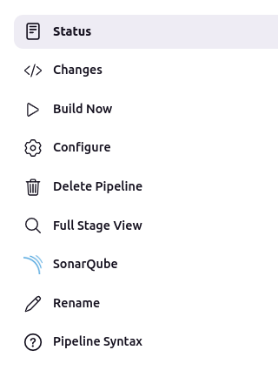

**4. click on build now → it will take about 10–15 min**

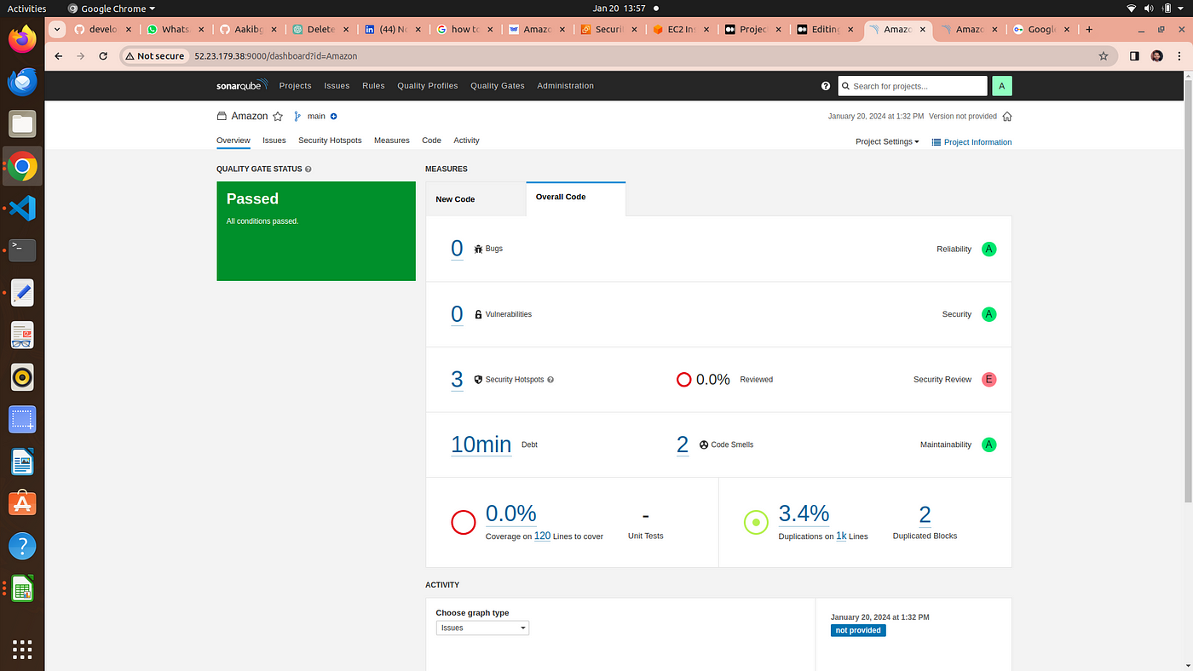

sonarqube output

**5. you could checkout the console output**

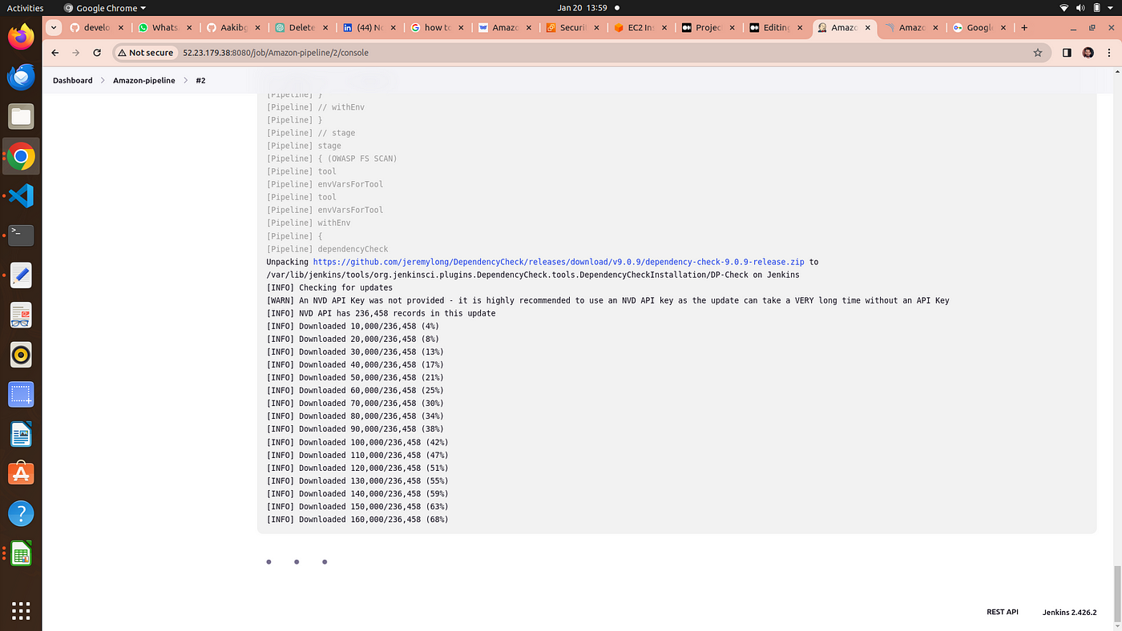

wait for completion

**6. owasp dependency check result**

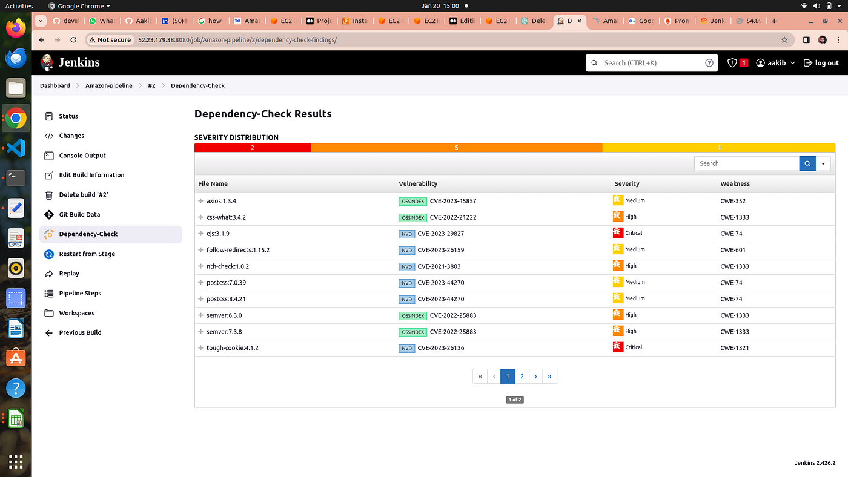

## 7. After a lot of error we did it

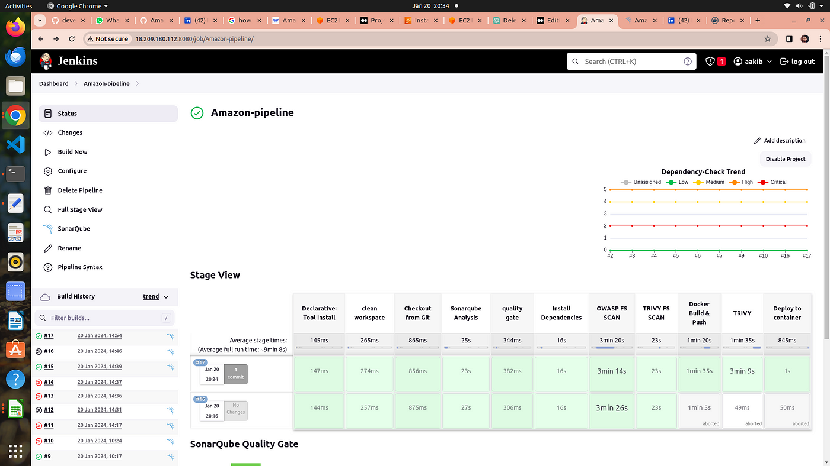

8. Now our docker image is build,push and deployed into a container and our app is live and running on port no. 3000

## to check →http://<your-public-ip>:3000



## Here’s is our amazon app

# Step5 →Monitering via Prmotheus and grafana

**Prometheus** is like a detective that constantly watches your software and gathers data about how it’s performing. It’s good at collecting metrics, like how fast your software is running or how many users are visiting your website.

**Grafana**, on the other hand, is like a dashboard designer. It takes all the data collected by Prometheus and turns it into easy-to-read charts and graphs. This helps you see how well your software is doing at a glance and spot any problems quickly.

In other words, Prometheus collects the information, and Grafana makes it look pretty and understandable so you can make decisions about your software. They’re often used together to monitor and manage applications and infrastructure.

# 1. Setup another server or EC2 for moniterning

go to ec2 console and launch an instance having a base image ofu buntu and with t2.medium specs because **Minimum Requirements to Install Prometheus :**

2 CPU cores.

4 GB of memory.

20 GB of free disk space.

# 2. Installing Prometheus:

**First, create a dedicated Linux user for Prometheus and download Prometheus:**

sudo useradd — system — no-create-home — shell /bin/false prometheus  
wget <https://github.com/prometheus/prometheus/releases/download/v2.47.1/prometheus-2.47.1.linux-amd64.tar.gz>

**2. Extract Prometheus files, move them, and create directories:**

tar -xvf prometheus-2.47.1.linux-amd64.tar.gz  
cd prometheus-2.47.1.linux-amd64/  
sudo mkdir -p /data /etc/prometheus  
sudo mv prometheus promtool /usr/local/bin/  
sudo mv consoles/ console_libraries/ /etc/prometheus/  
sudo mv prometheus.yml /etc/prometheus/prometheus.yml

**3. Set ownership for directories:**

useradd prometheus  
sudo chown -R prometheus:prometheus /etc/prometheus/ /data/

**4. Create a systemd unit configuration file for Prometheus:**

sudo nano /etc/systemd/system/prometheus.service

Add the following code to the prometheus.service file:

[Unit]  
Description=Prometheus  
Wants=network-online.target  
After=network-online.targetStartLimitIntervalSec=500  
StartLimitBurst=5[Service]  
User=prometheus  
Group=prometheus  
Type=simple  
Restart=on-failure  
RestartSec=5s  
ExecStart=/usr/local/bin/prometheus \  
 --config.file=/etc/prometheus/prometheus.yml \  
 --storage.tsdb.path=/data \  
 --web.console.templates=/etc/prometheus/consoles \  
 --web.console.libraries=/etc/prometheus/console_libraries \  
 --web.listen-address=0.0.0.0:9090 \  
 --web.enable-lifecycle[Install]  
WantedBy=multi-user.target

**b.** press →**ctrl+o** #for save and then **ctrl+x** #for exit from the file

Here’s a explanation of the key parts in this above file:

User and Group specify the Linux user and group under which Prometheus will run.

ExecStart is where you specify the Prometheus binary path, the location of the configuration file (prometheus.yml), the storage directory, and other settings.

web.listen-address configures Prometheus to listen on all network interfaces on port 9090.

web.enable-lifecycle allows for management of Prometheus through API calls.

**5. Enable and start Prometheus:**

sudo systemctl enable prometheus  
sudo systemctl start prometheussudo systemctl status prometheus

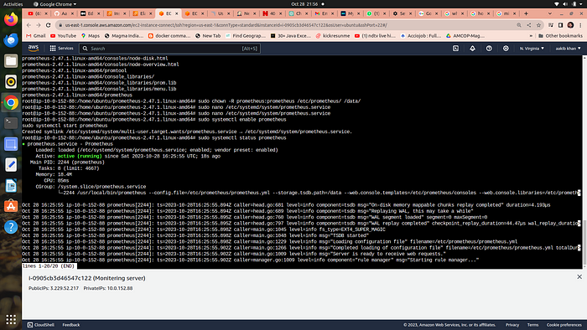

**Now go to your security group of your ec2 to enable port 9090 in which prometheus will run**

go to → [http://public_ip:9090](http://public_ip:9090/) to see the webpage of prometheus

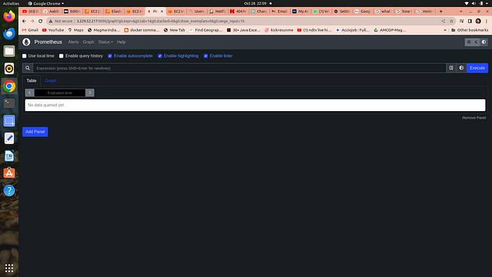

# 3. Installing Node Exporter:

Node exporter is like a “reporter” tool for Prometheus, which helps collect and provide information about a computer (node) so Prometheus can monitor it. It gathers data about things like CPU usage, memory, disk space, and network activity on that computer.

A Node Port Exporter is a specific kind of Node Exporter that is used to collect information about network ports on a computer. It tells Prometheus which network ports are open and what kind of data is going in and out of those ports. This information is useful for monitoring network-related activities and can help you ensure that your applications and services are running smoothly and securely.

Run the following commands for installation

**Create a system user for Node Exporter and download Node Exporter:**

sudo useradd — system — no-create-home — shell /bin/false node_exporterwget <https://github.com/prometheus/node_exporter/releases/download/v1.6.1/node_exporter-1.6.1.linux-amd64.tar.gz>

**2. Extract Node Exporter files, move the binary, and clean up:**

tar -xvf node_exporter-1.6.1.linux-amd64.tar.gz  
sudo mv node_exporter-1.6.1.linux-amd64/node_exporter /usr/local/bin/  
rm -rf node_exporter*

**3. Create a systemd unit configuration file for Node Exporter:**

sudo nano /etc/systemd/system/node_exporter.service

add the following code to the node_exporter.service file:

provide more detailed information about what might be going wrong. For example:

[Unit]  
Description=Node Exporter  
After=network.target  
  
[Service]  
User=node_exporter  
Group=node_exporter  
Type=simple  
ExecStart=/usr/local/bin/node_exporter  
  
[Install]  
WantedBy=default.target

**4. Enable and start Node Exporter:**

sudo useradd -m -s /bin/bash node_exporter sudo chown node_exporter:node_exporter /usr/local/bin/node_exportersudo systemctl daemon-reload  
sudo systemctl start node_exporter  
sudo systemctl enable node_exporter  
sudo systemctl status node_exporter

**node exporter service is now running**

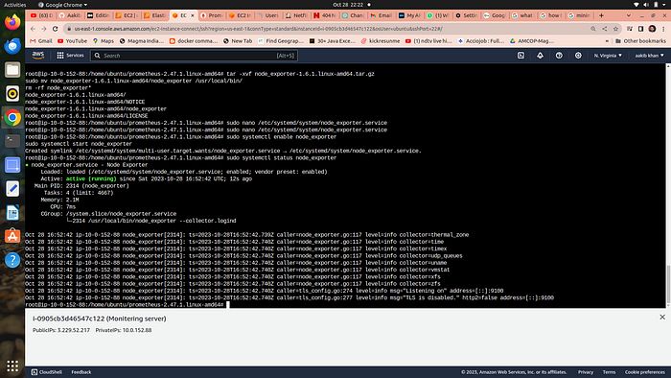

You can access Node Exporter metrics in Prometheus.

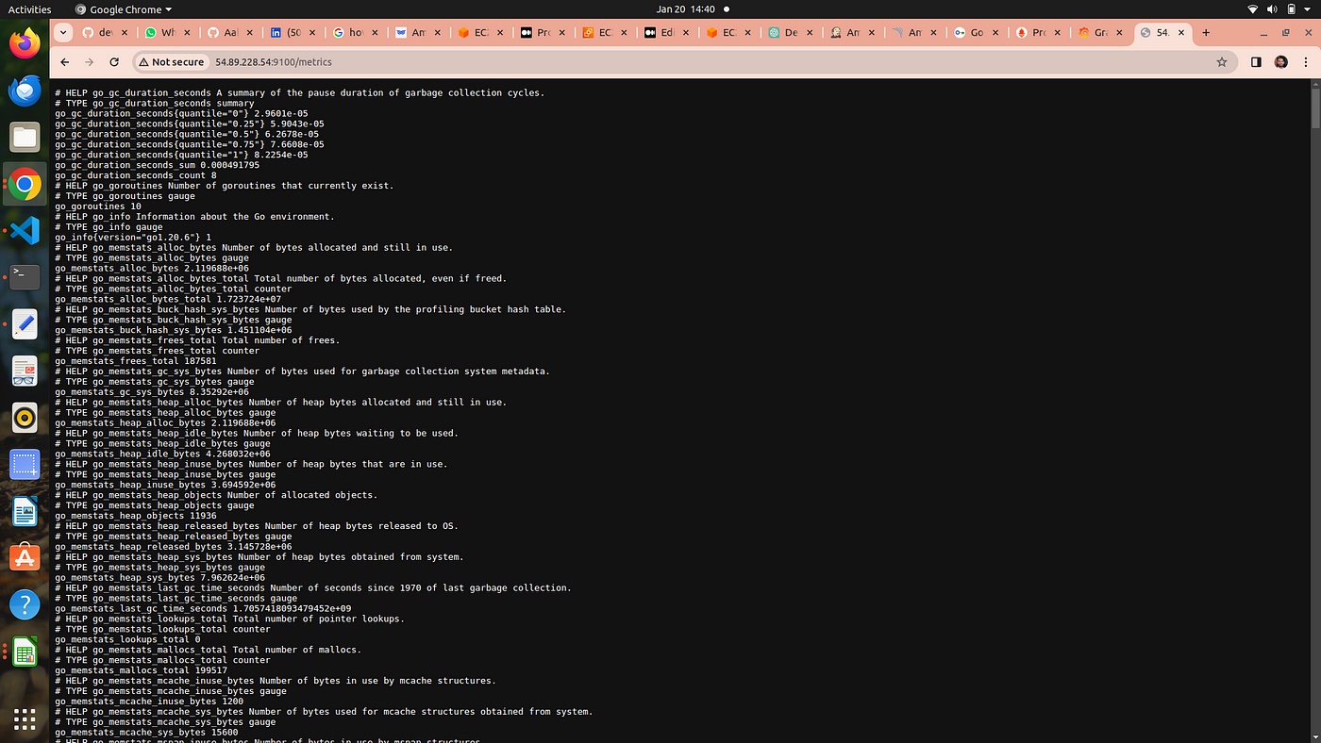

publicip:9100

# 5. Configure Prometheus Plugin Integration:

go to your EC2 and run →

cd /etc/prometheus

2. you have to edit the prometheus.yml file to moniter anything

scrape_configs:  
 - job_name: 'node_exporter'  
 static_configs:  
 - targets: ['localhost:9100']  
 - job_name: 'jenkins'  
 metrics_path: '/prometheus'  
 static_configs:  
 - targets: ['<your-jenkins-ip>:<your-jenkins-port>']

**add the above code with proper indentation like this →**

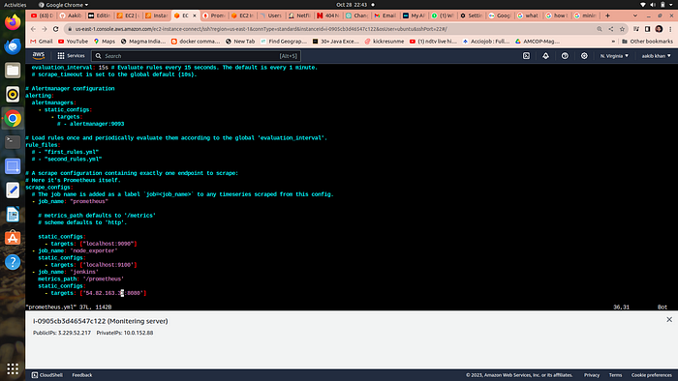

press esc+:wq to save and exit

**a. Check the validity of the configuration file →**

promtool check config /etc/prometheus/prometheus.yml

***o/p →success***

**b.** Reload the Prometheus configuration without restarting →

**curl -X POST** [**http://localhost:9090/-/reload**](http://localhost:9090/-/reload)

**go to your prometheus tab again and click on status and select targets you will there is three targets present as we enter in yaml file for moniterning**

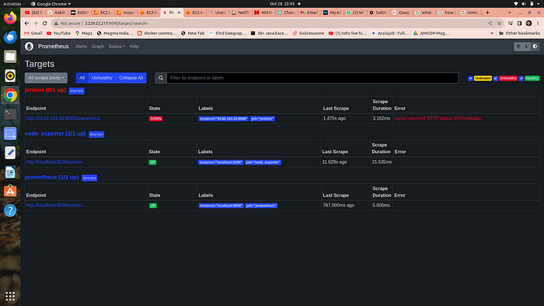

prometheus targets dashboard

# 5. Setup Grafana

**Install Dependencies:**

sudo apt-get update  
sudo apt-get install -y apt-transport-https software-properties-common

**Add the GPG Key for Grafana:**

wget -q -O — <https://packages.grafana.com/gpg.key> | sudo apt-key add -

**Add the repository for Grafana stable releases:**

echo “deb <https://packages.grafana.com/oss/deb> stable main” | sudo tee — a /etc/apt/sources.list.d/grafana.list

**Update the package list , install and start Grafana:**

sudo apt-get update  
sudo apt-get -y install grafanasudo systemctl enable grafana-serversudo systemctl start grafana-serversudo systemctl status grafana-server

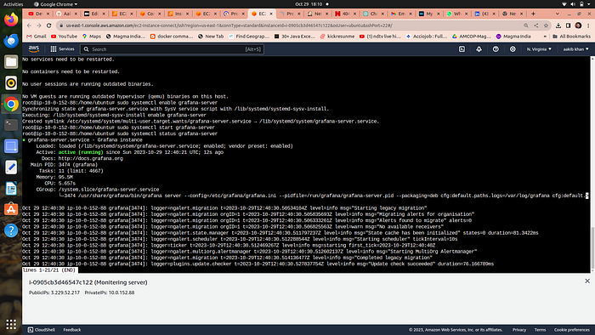

**Now go to your ec2 security group and open port no. 3000 in which grafana runs**

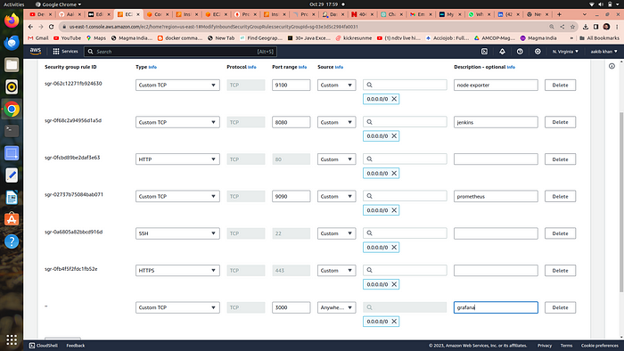

Go and browse [http://public_ip:3000](http://public_ip:3000/) to access your grafana web interface

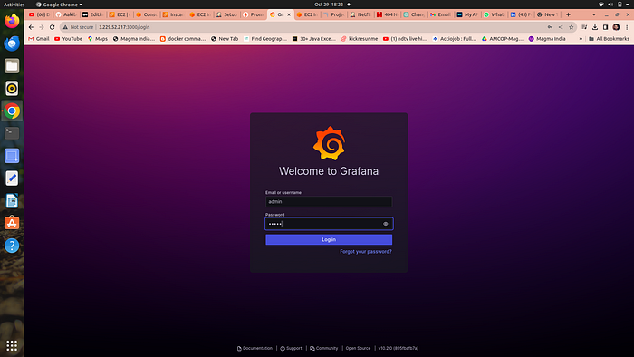

**username = admin, password =admin**

# 6. Add Prometheus Data Source:

To visualize metrics, you need to add a data source.

**Follow these steps:**

Click on the gear icon (⚙️) in the left sidebar to open the “Configuration” menu.

Select “Data Sources.”

Click on the “Add data source” button.

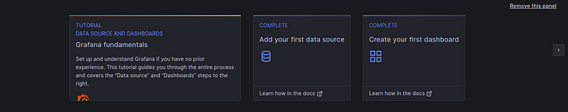

Choose “Prometheus” as the data source type.

In the “HTTP” section:

Set the “URL” to <http://localhost:9090> (assuming Prometheus is running on the same server).

Click the “Save & Test” button to ensure the data source is working.

# 7. Import a Dashboard

Importing a dashboard in Grafana is like using a ready-made template to quickly create a set of charts and graphs for monitoring your data, without having to build them from scratch.

Click on the “+” (plus) icon in the left sidebar to open the “Create” menu.

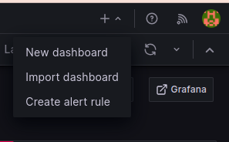

Select “Dashboard.”

Click on the “Import” dashboard option.

Enter the dashboard code you want to import (e.g., code 1860).

Click the “Load” button.

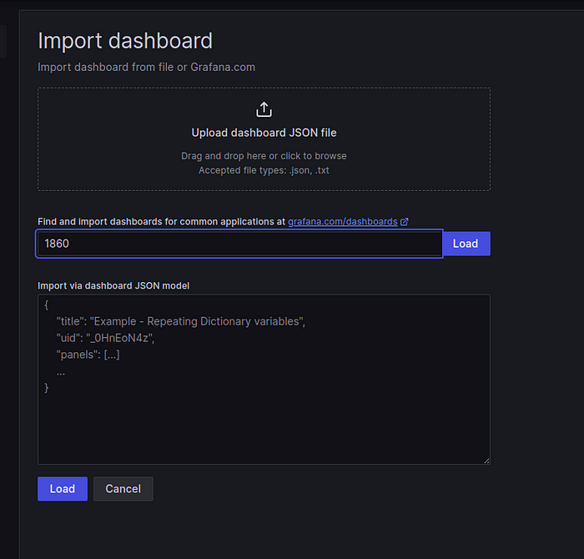

Select the data source you added (Prometheus) from the dropdown.

Click on the “Import” button.

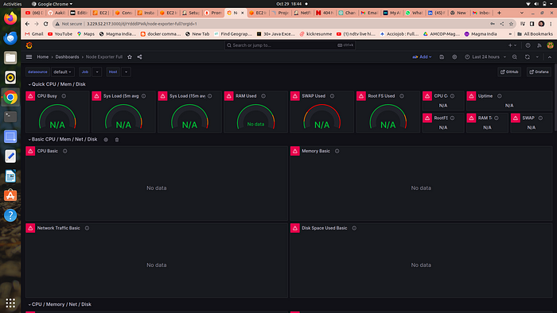

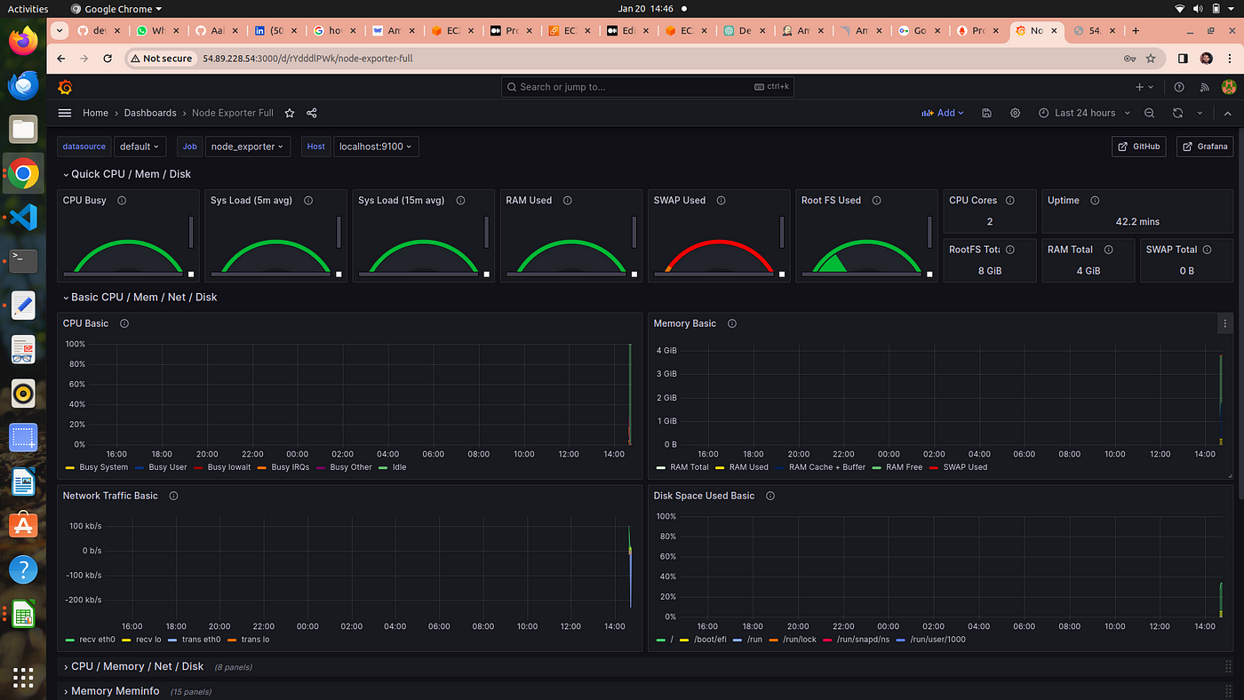

# 8. Configure global setting for promotheus

go to manage jenkins →system →search for promotheus — apply →save

# 9. import a dashboard for jenkins

Click on the “+” (plus) icon in the left sidebar to open the “Create” menu.

Select “Dashboard.”

Click on the “Import” dashboard option.

Enter the dashboard code you want to import (e.g., code 9964).

Click the “Load” button.

Select the data source you added (Prometheus) from the dropdown.

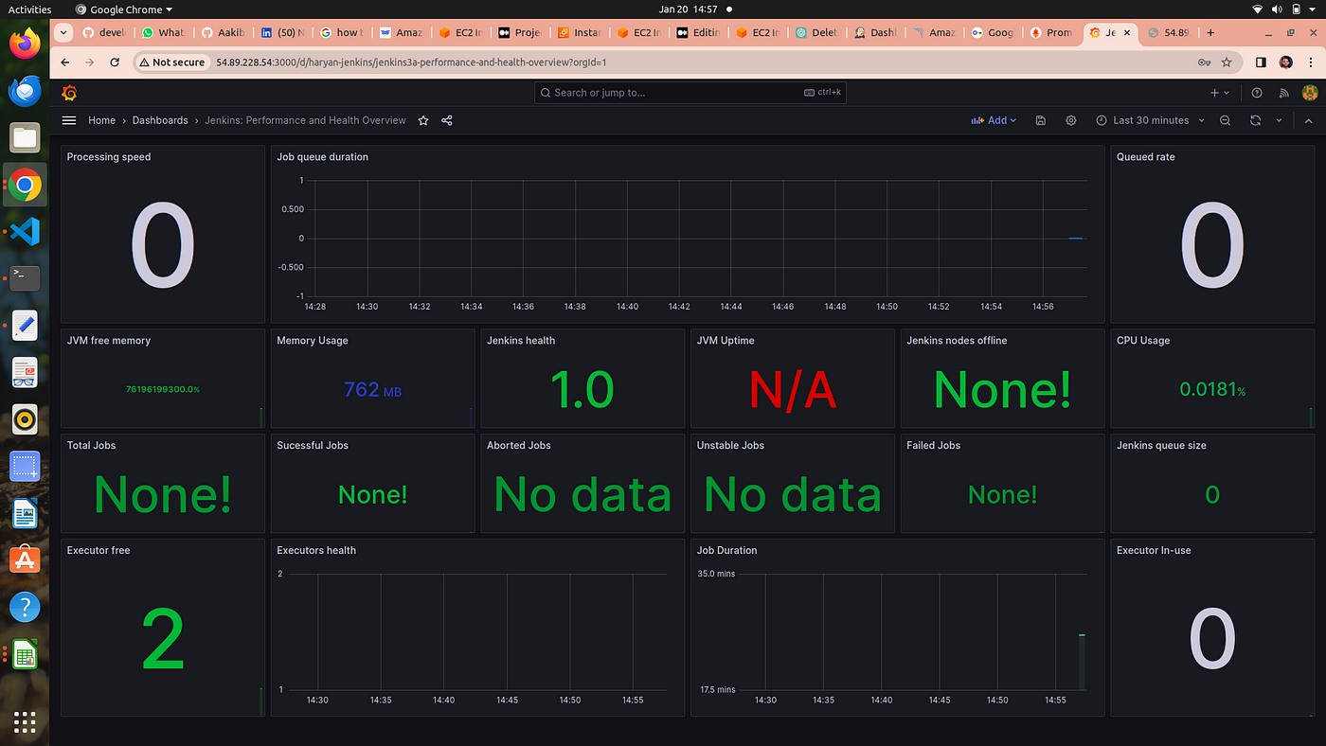



**This is our app running on port no.3000**

# Step 6 → Terraform Destroy

**go to your terminal and run**

terraform destroy

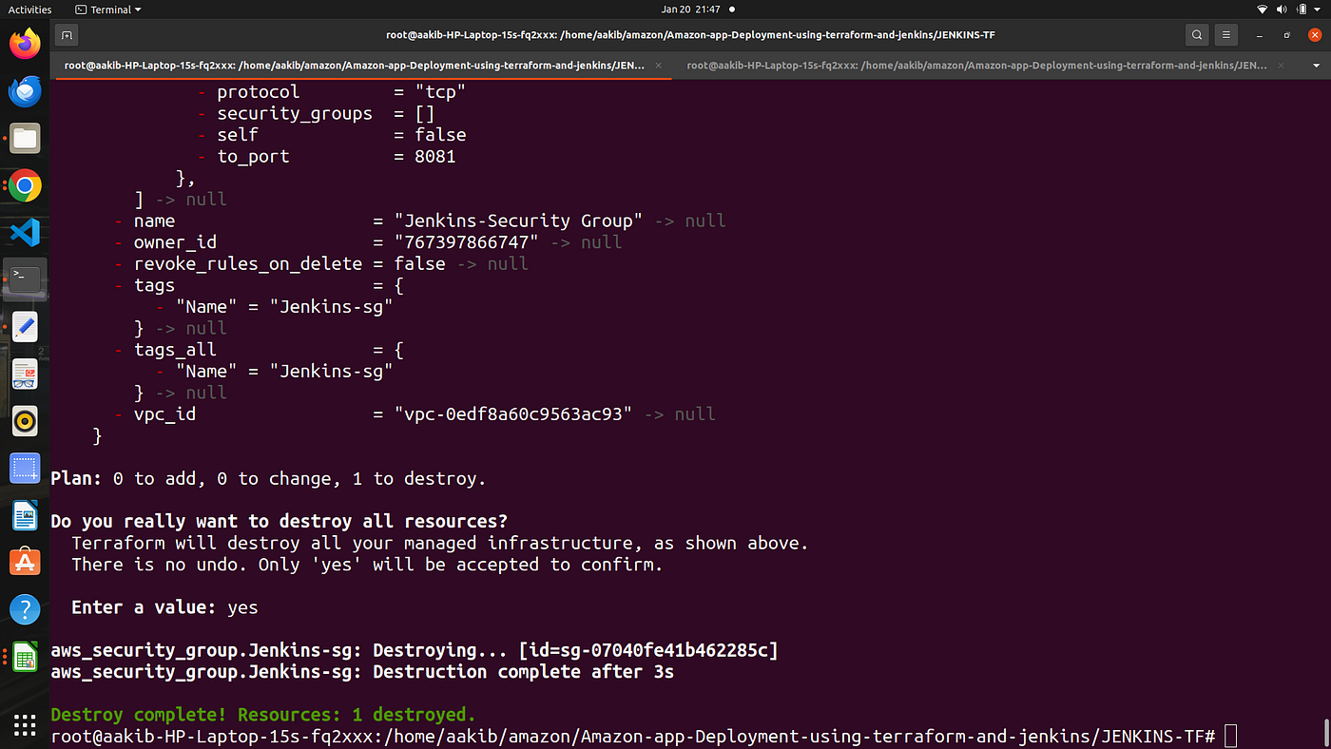

**Destroy complete**